Detecting Potholes using Image processing

Abstract: This project aims to detect potholes on road surfaces using image processing techniques. By capturing road images through cameras, we preprocess the images through grayscale conversion, noise reduction, and edge detection. Key features such as shape and texture are extracted to identify potential potholes. Segmentation methods help break down the images into manageable regions, which are then analyzed using classification algorithms or deep learning models like Convolutional Neural Networks (CNNs). The final output provides accurate detection and mapping of potholes, offering valuable insights for road maintenance and safety improvements.

Code:
from IPython import get_ipython
from IPython.display import display
# %%
import cv2
import numpy as np
from google.colab.patches import cv2_imshow # Import cv2_imshow from google.colab.patches

# Load the image
image_path = '/content/pot' # Replace with the actual path to your image
image = cv2.imread(image_path)

# Check if image loading was successful
if image is None:
print(f"Error: Could not load image from {image_path}. Please check the path and file permissions.")
else:
# Convert the image to grayscale
gray = cv2.cvtColor(image, cv2.COLOR_BGR2GRAY)

# Apply Gaussian Blur to reduce noise
blurred = cv2.GaussianBlur(gray, (5, 5), 0)

# Use Canny edge detection
edges = cv2.Canny(blurred, 50, 150)

# Display the edge-detected image using cv2_imshow
cv2_imshow(edges) # Replace cv2.imshow with cv2_imshow
#cv2.waitKey(0) # These lines are not needed with cv2_imshow
#cv2.destroyAllWindows()
# %%
Input :
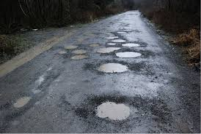
Output :
